### MarkingSemester One Examination, 2019

### Question/Answer booklet

# MATHEMATICS SPECIALIST

**UNIT 3**

## Section One:

## Calculator-free

|  |
| --- |
|  |

Your Name

Your Teacher’s Name

## Time allowed for this section

Reading time before commencing work: five minutes

Working time: fifty minutes

## Materials required/recommended for this section

***To be provided by the supervisor***

This Question/Answer booklet

Formula sheet

***To be provided by the candidate***

Standard items: pens (blue/black preferred), pencils (including coloured), sharpener, correction fluid/tape, eraser, ruler, highlighters

Special items: nil

## Important note to candidates

No other items may be taken into the examination room. It is **your** responsibility to ensure that you do not have any unauthorised material. If you have any unauthorised material with you, hand it to the supervisor **before** reading any further.

**Structure of this paper**

|  |  |  |  |  |  |
| --- | --- | --- | --- | --- | --- |
| Section | Number of questions available | Number of questions to be answered | Working time (minutes) | Marks available | Percentage of examination |
| Section One:  Calculator-free | 7 | 7 | 50 | 49 | 34.5 |
| Section Two:  Calculator-assumed | 13 | 13 | 100 | 93 | 65.5 |
|  |  |  |  | **Total** | 100 |

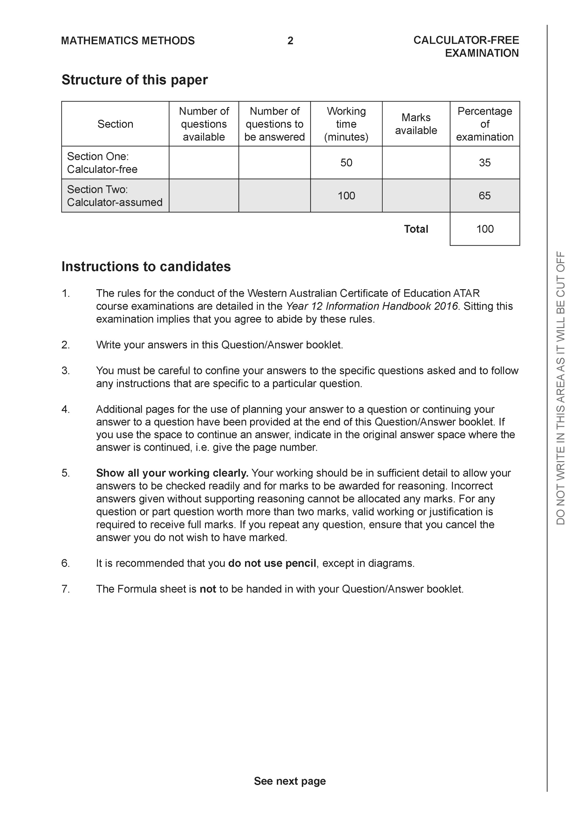

**Section One: Calculator-free (49 Marks)**

This section has **seven (7)** questions. Answer **all** questions. Write your answers in the spaces provided.

Spare pages are included at the end of this booklet. They can be used for planning your responses and/or as additional space if required to continue an answer.

● Planning: If you use the spare pages for planning, indicate this clearly at the top of the page.

● Continuing an answer: If you need to use the space to continue an answer, indicate in the original answer space where the answer is continued, i.e. give the page number. Fill in the number of the question that you are continuing to answer at the top of the page.

Working time: 50 minutes.

**Question 1 (8 marks)**

Let  and .

1. Determine  (2 marks)

|  |
| --- |
| **Solution** |
|  |
| **Specific behaviours** |
| 🗸 subs g into g  🗸 simplifies expression |

1. Does  exist over the natural domain of  ? Explain. (2 marks)

|  |
| --- |
| **Solution** |
|  |
| **Specific behaviours** |
| 🗸 states range and domain  🗸 states not exist |

1. Determine  (simplify) and its natural domain. (4 marks)

|  |
| --- |
| **Solution** |
|  |
| **Specific behaviours** |
| 🗸 subs g into f  🗸 simplify expression  🗸 lower limit of domain (excluded)  🗸upper limit of domain (included) |

**Question 2 (4 marks)**

Let  where  are real constants. Determine all possible value(s) of .

|  |
| --- |
| **Solution** |
|  |
| **Specific behaviours** |
| 🗸 multiplies both sides by denominator  🗸 obtains two simultaneous eqns  🗸 obtains quadratic eqn for one variable  🗸obtains two pairs of values |

**Question 3 (6 marks)**

Solve for in the following system of linear equations.



|  |
| --- |
| **Solution** |
|  |
| **Specific behaviours** |
| 🗸 eliminates one variable from one equation  🗸 eliminates one variable from two equations  🗸 eliminates two variables from one equation  🗸solves for one variable  🗸 solves for two variables  🗸solves all three variables  NOTE: No need to use gaussian elimination method |

**Question 4 (6 marks)**

Sketch the following function on the axes below showing all major features.



|  |
| --- |
| **Solution** |
|  |
| **Specific behaviours** |
| 🗸 shows dotted lines for both vertical asymptotes  🗸 shows dotted line for horizontal asymptote for far left and right  🗸 labels equation of all 3 asymptotes  🗸shows y intercept  🗸 correct shape in 2 sections  🗸correct shape in all 3 sections |

**Question 5 (9 marks)**

1. Determine all roots of  in exact polar form with principal arguments.

(4 marks)

|  |
| --- |
| **Solution** |
|  |
| **Specific behaviours** |
| 🗸 determines modulus(no need to simplify)  🗸 uses De Moivre’s Theorem to find one argument  🗸 determines three principal arguments(no need to simplify)  🗸determines all six principal arguments(no need to simplify) |

1. Plot all of these roots on the graph below showing all major features. (2 marks)

|  |
| --- |
| **Solution** |
|  |
| **Specific behaviours** |
| 🗸 shows scale  🗸 six points equally spaced and positioned correctly |

1. If all the consecutive roots are joined by a straight line, determine the exact area of the polygon formed. (3 marks)

|  |
| --- |
| **Solution** |
| 6 equilateral triangles |
| **Specific behaviours** |
| 🗸 uses equilateral triangles  🗸 determines area of one triangle  🗸determines simplified exact area in total |

**Question 6 (7 marks)**

Determine all solutions of the following equations.

1.  and express in exact polar form with principal arguments.

(4 marks)

|  |
| --- |
| **Solution** |
|  |
| **Specific behaviours** |
| 🗸 uses quadratic formula to express  in two polar forms  🗸 uses De Moivre’s to square root  🗸 obtains two roots in polar principle arguments  🗸obtains the conjugates of these roots |

1.  and express in exact cartesian form. (3 marks)

|  |
| --- |
| **Solution** |
|  |
| **Specific behaviours** |
| 🗸 uses quadratic formula  🗸 expresses discriminant in polar form  🗸obtains two roots in exact cartesian form |

**Question 7 (9 marks)**

A, B & C are 3 distinct points with non-zero position vectors  respectively.

1. If  what can be deduced about  and ? Explain. (3 marks)

|  |
| --- |
| **Solution** |
|  |
| **Specific behaviours** |
| 🗸 uses distributive law  🗸 shows AB cross c is zero  🗸states parallel |

1. If  what relationship exists between ? (3 marks)

|  |
| --- |
| **Solution** |
|  |
| **Specific behaviours** |
| 🗸 express c in terms of a & b  🗸 expands b cross c in terms of a & b  🗸shows pairs are equal |

1. If  and , prove that  for some scalar . (3 marks)

|  |
| --- |
| **Solution** |
|  |
| **Specific behaviours** |
| 🗸 uses distributive law  🗸 negative used when changing order of cross  🗸shows parallel |

Additional working space

Question number:

Additional working space

Question number:

Additional working space

Question number:

**Acknowledgements**